ASSIGNMENT 1

PRATHAMESH SATHE

ROLL NO.:59

CODE: -

hash_table = [[] for i in range(10)]

def display_function(hash_table):

for i in range(len(hash_table)):

print(i,end = "")

for j in hash_table[i]:

print("", end = " ")

print(j, end = "")

print()

#def hash_function(key):

# return key%10

def insert(hash_table,key , key_value):

index = hash_function(hash_table,key)

hash_table[index] = key_value

def hash_function(hash_table,key) :

# Hash function h(x) = x%10

index = key%10

if hash_table[index] == [] :

return index

else :

# Implementing linear probing

while hash_table[index] != [] :

index = (index+1)%10

return index

num = int(input("Enter the no of clients : "))

for i in range(num):

telephone_no = int(input("Enter the telephone no of client "))

name = input("Enter the name of the client ")

insert(hash_table,telephone_no,name)

display_function(hash_table)

OUTPUT:-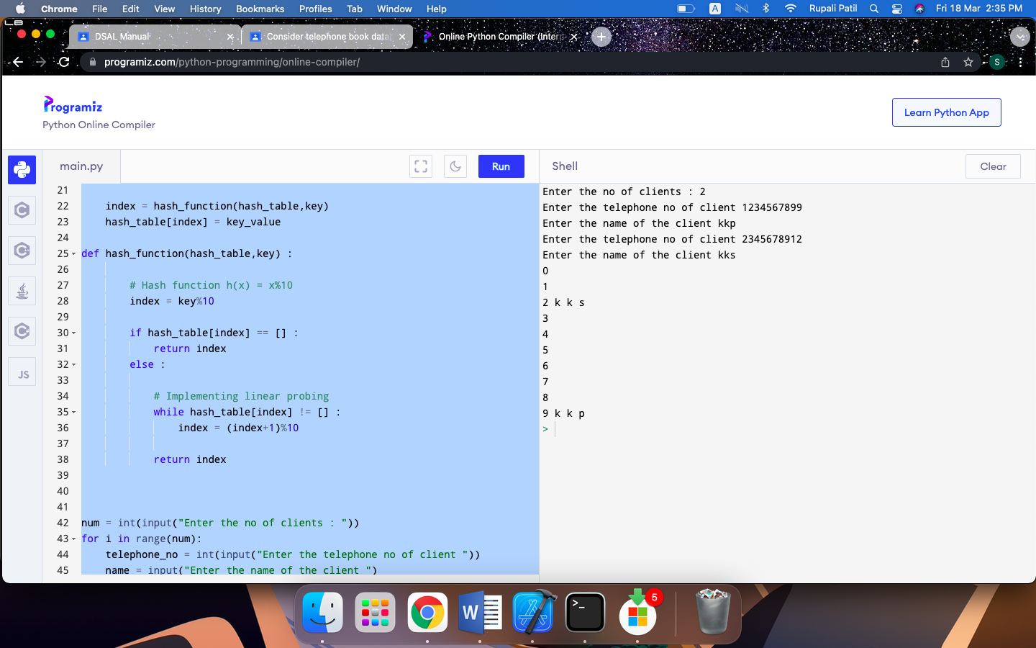s